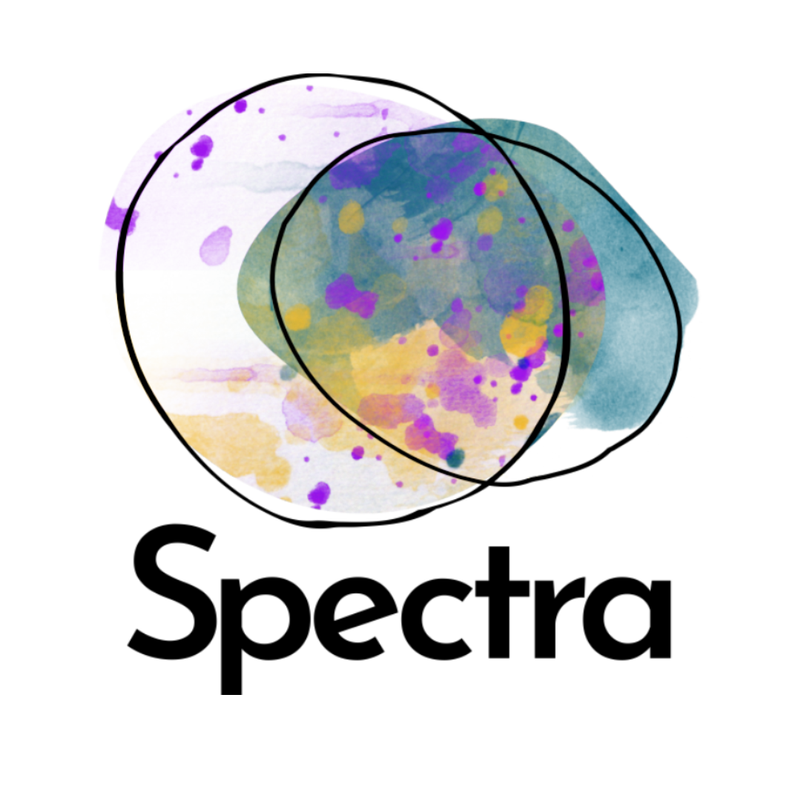
BOSS. Recruitment Pack
If you need or would prefer this job description or the application form in another format, please contact kerry@wearespectra.co.uk.

About Spectra
Spectra is an arts company that works with people with learning disabilities to make positive change in their own lives, their communities and the world around them.

We’re based in Sandwell and have been making work since 2014. We make performances, visual artwork and gardens. You can find out more about Spectra on our website.

What is BOSS. and who is it for?
BOSS. is a training programme for learning disabled people who are passionate about the arts making a positive difference in the world. These Trainee roles are very creative but they are not about making art. BOSS. Trainees will create opportunities for other learning disabled people to make art and to make change. Trainees will learn skills about how to manage an arts organisation.

We are looking for people based in Sandwell, Birmingham or Dudley who want to keep working with us after the programme is finished. The Trainees we choose will be ambitious and committed. You don’t need lots of experience because that’s what this opportunity will give you. You just need to be excited about learning and how the arts can make change.

What will a BOSS. Trainee do?
BOSS. will last one year. Two Trainees will learn about being managers in an arts organisation. Both Trainees will work with the Spectra staff team.First, we’ll spend some time making sure our Trainees feel welcome and well supported. As the year goes on, they will get more deeply involved with our work.

- Trainees will choose the area of work to focus on. This might be:
  - Planning big projects
  - Helping other people with learning disabilities with their ideas
  - Finding money for projects
  - Finding audiences for projects
  - How to hire people
  - Supporting people on your team
  - Making projects accessible
  - How to run conferences & big events
- Trainees will learn from experienced team members. Trainees will watch experienced team members do tasks lots of times, and talk about how they do it.
- When Trainees understand how to do a task, they will do it together with experienced team members.
- Trainees will be supported to develop the skills they need to do tasks independently.
- They’ll have lots of opportunities to talk through what they’ve learned, any changes Spectra can make to help the trainees learn better, and what they want to learn next.

Who will you be working with?
Spectra is a warm and friendly place to work. We work hard - and we also laugh a lot. There are 7 Staff members who work in the office, who will be the people the Trainees work with the most. You can learn more about them here. We also work with lots of freelance artists and our supportive Steering Group and Board, who help us to plan our work and make sure we’re doing it well.

The Trainees will also have an Access Support Worker, who they will help to choose. The Support Worker will support the Trainees’ practical needs during the traineeship.

When and where will BOSS. take place?
BOSS. will run from September 2026 - September 2027. The programme will mostly take place during school term time.

You will work 1 to 1.5 days a week. Some of this time will be on Tuesdays in our office. You may also visit workshops or attend meetings in community locations.

We will support you with transport and be as flexible as possible around your schedule outside of work with us.

What will you be paid?
You will be paid £195 per day. The traineeship takes place over 49 days across the year. This means the total fee over the year of the traineeship will be £9,555.

If you are in receipt of income-related benefits, such as Universal Credit or Employment Support Allowance, we will work with you to agree a payment schedule that works best for you.

What do we mean by learning disabled?
Lots of people who apply to work with Spectra have questions about what we mean by learning disabled. This is really tricky to define because it’s different for everyone and no two people are the same. We think it’s important to try to define the differences so that people who have the most barriers to accessing work get the support we are offering.

Mencap has a good video here that helps to explain.

People can have learning disabilities and learning difficulties but they aren't the same.

- a learning difficulty is a specific learning need that usually becomes clear when a person enters education, for example dyslexia or dyspraxia.
- a learning disability is made up of emotional, social and learning needs that become clear soon after birth or in the early years, and will last a person’s whole life.

People with a learning disability may also be neurodivergent (such as having ADHD or being autistic). Neurodivergent people do not necessarily have a learning disability.
We will not ask for evidence of your disability, but this role is specifically for people with learning disabilities

Support ahead of applying
Is this right for me?

If you’re interested in BOSS. but not sure if the programme is right for you, please get in touch for a chat. We’re very happy to talk about the programme and answer any questions. Email kerry@wearespectra.co.uk to book a chat.
Taster Sessions
We are offering optional taster sessions for anyone who would like to better understand the kinds of tasks that the Trainees will be working on. They might help you to decide whether you want to apply for the Traineeship, and what skills you may be interested in developing if you are successful.
You can come to one taster, multiple tasters, or none at all. Attendance will not impact how your application is assessed.
Dates:
- Running a Meeting (how to prepare for and host a meeting): Wednesday 6 May, 1.30pm - 3pm
- Marketing (how to excite people about an event): Tuesday 12 May, 11am - 12.30pm
- Finance (how to manage money for a project - without maths!): Monday 18 May, 4pm - 5.30pm
Venue: Lightwoods House, Adkins Lane, Smethwick, Sandwell, B67 5DP
To find out more and sign up for a taster session, please fill out this short form.
Application Support Sessions
If you want support thinking through what to put in your application or submitting it, we will be running Application Support Sessions in person and online.
In-person Support Sessions will be at Lightwoods House, Adkins Lane, Bearwood, Smethwick, B67 5DP on:
- Wednesday 20th May (1pm-5pm); and
- Friday 29th May (12pm-4pm).
To sign up for a one-hour slot, please email kerry@wearespectra.co.uk with your name, the date and time you would like to attend, and your access needs.
Online Support Sessions are available on various dates. To book an online session, please click here. If you need support with booking, please email kerry@wearespectra.co.uk.

Timeline and Key Dates
Wed 6 May: Running a Meeting taster session, 1.30pm-3pm
Tues 12 May: Marketing taster session, 11am-12.30pm
Mon 18 May: Finance taster session, 4pm-5.30pm

Wed 20 May: In-person Application Support Sessions, 1pm-5pm
Fri 29 May: In-person Application Support Sessions, 12pm-4pm

Tues 02 June: Application deadline, 9am
Wed 03 June: Spectra will read, listen and watch all applications and decide who they want to invite to informal interviews
Thurs 04 June: Emails to everybody to let them know whether they have been invited to an informal interview or not
Tue 09 June: Informal interviews, in person at our office at Lightwoods House in Bearwood

Sept 2026 - Sept 2027: Traineeship (mostly in person in Bearwood)

How do you apply?
Answer the questions below on the application form or in a video or voice recording. Send the video or submit the application form by the closing date of Tuesday 2 June at 9am.

Application Questions
Eligibility Questionnaire
Do you have a learning disability?
Are you available on Tuesdays?
Do you live in Sandwell, Birmingham or Dudley?

Application Questions
- What is your name?
- What pronouns do you use?
- What is your phone number?
- What is your email address?
- Is there someone else you would like us to include when we contact you? Please give us their name and contact details.
- Tell us about your interest and experience in the arts.
- Tell us how you think the arts can make change in the world.
- Tell us about your long term work goals.
- Why do you want to be a trainee at Spectra?
- Tell us about a time when you learned a new skill. How did you learn that skill?
- What kind of support will you need on this programme? Think about the kind of support you needed at school or at other jobs. This will help us make sure that we can support you well.

Monitoring Information
- What is your ethnicity? Ethnic origin is not about nationality, place of birth or citizenship. It is about the group to which you perceive you belong.
- Do you consider yourself to have a disability or health condition?
- How do you describe your gender identity?
- Do you identify as LGBTQIA+?
- Do you identify as working class or from a working class background?

Marketing Questions
Where did you hear about this opportunity?
Would you like to be added to our mailing list?

Equitable Opportunities
This is an opportunity specifically for learning disabled people because we believe they face unfair barriers to working. We understand that learning disabled people may experience barriers due to other aspects of their lived experience. We are committed to creating a working space that is safe and caring for all.
If you need or would prefer this job description or the application form in another format, please don’t hesitate to contact kerry@wearespectra.co.uk.
