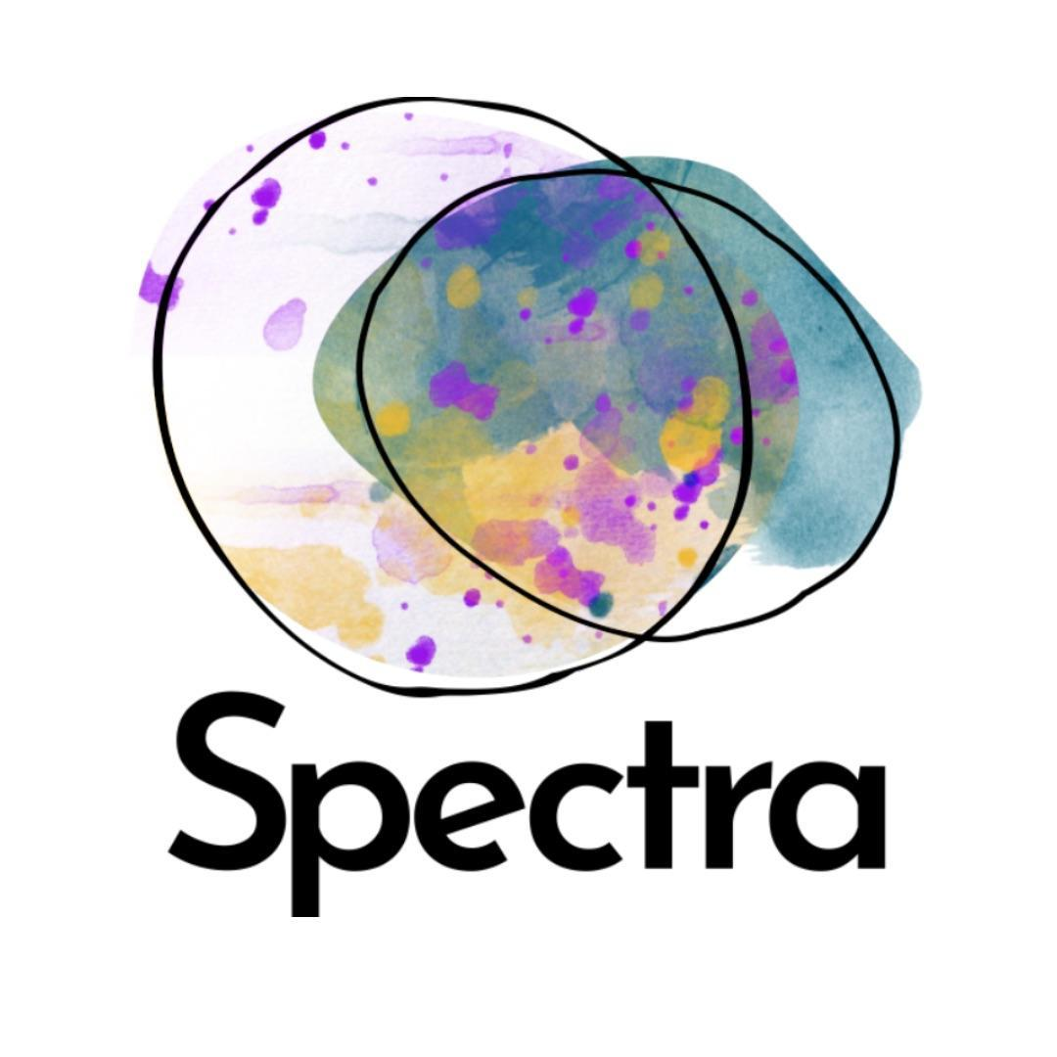
Bullying & Harassment Policy

- Introduction

Spectra expects standards of behaviour which respect the dignity of all individuals at work and regards any form of harassment as unacceptable behaviour.

Spectra believes in eliminating all forms of harassment, intimidation and victimisation in the workplace and is committed to the development of a working environment in which all staff and volunteers can work effectively and without unwanted attention, as recommended in the European Code of Practice on the protection of the dignity of people at work.

In line with the policy, any employee or trustee with management and/or supervisory responsibility will take steps to eliminate harassment of which they are either aware or which has been brought to their attention. All employees have a duty to comply with this policy and failure to do so is a disciplinary offence.

2. Definition of Harassment and Bullying

Harassment is unwanted and unacceptable behaviour which is unreasonable, unwelcome and/or offensive. It may be physical, verbal or non-verbal and might be directed against an individual or arise in a gathering such as the workplace, a meeting, public gathering or party.

Harassment is unwanted conduct which is related to one of the following; age, disability, gender reassignment, marriage and civil partnership, pregnancy and maternity, race, religion or belief, sex and sexual orientation. Harassment is unlawful under the Equality Act 2010.

Bullying and harassment are not necessarily face to face. They may also occur in written communications, electronic email, phone and automatic supervision methods such as computer recording of downtime from work.

Workplace bullying is the persistent demeaning and downgrading of an individual through words or acts resulting in the undermining of their confidence or self-esteem.

This policy does not mean an end to the fun and banter which has always formed part of an amicable and healthy working environment. When this is based upon mutual acceptance it does not constitute harassment. However, when the behaviour is unwanted by the recipient and would therefore be regarded as harassment it will, if substantiated, be treated as a disciplinary offence.

3. What Constitutes Harassment

Harassment is “unwanted conduct related to a relevant constituted characteristic, which has the purpose or effect of violating an individual’s dignity or creating an intimidating, hostile, degrading, humiliating or offensive environment for that individual”.

Some grievances may seem trivial but added together can cause distress. Harassment may also be unintentional on the harasser’s part, but the victim may perceive it as such.

Detailed below are some areas in which this policy applies but it is not an exhaustive list and it is emphasised that all forms of harassment are subject to this policy.

All employees, volunteers, trustees, visitors and anyone acting on behalf of the organisation will be expected to adhere to this policy and will refrain from:

- Unwanted physical contact i.e. touching, patting or brushing against another employee’s body

- Unwanted verbal conduct such as unwelcome sexual advances, racist, sexist, homophobic or ableist comments, offensive remarks about age and/or disability, derogatory name calling, slogans, insults, ridicule of a person for differences, offensive jokes, pranks, abuse, threats or questions or comments of a personal nature

- Shouting, rudeness, yelling, swearing, sarcasm, spreading rumours and reacting to minor problems or issues with the same vehemence as a major one

- Unwanted non-verbal conduct including sexually suggestive gestures, staring, leering and pestering

- Unwanted abuse of status such as overbearing supervision or individuals receiving unfair treatment based on characteristics such as age, culture, gender, disabilities, ethnic origin, sexuality, race or religion

- Offensive emails, text messages or social media content or the display of offensive materials

- Unwanted jokes, banter, mocking, mimicking or belittling a person

- Persistently picking on people in front of others or in private

- Blocking promotion and training opportunities

- Setting a person up to fail by overloading them with work or setting impossible deadlines.

4. Procedures for Eliminating Harassment

People do not always feel able or confident enough to complain, particularly if the harasser is a manager or senior member of staff. Sometimes they will simply resign. It is therefore very important for employers to ensure that staff are aware of options available to them to deal with potential bullying or harassment, and that these remain confidential.

- Informal Procedure

- Each individual has the right to, and is encouraged to, confront the harasser with a view to convey to them that their behaviour is unwanted and offensive and must therefore stop. Should the harasser cease at this stage, no further action will be required.

- The harasser may not be aware that their behaviour is offensive, and this approach could resolve the problem.

- However, if this initial approach is too difficult or embarrassing, the complainant can request that a third party (e.g. a work colleague) either make the approach for them or be present at the approach.

- It is however recommended that the complainant keep a diary note of the event(s) and the informal approach made.

- Formal Procedure

- If the harassment continues after the complainant has made it clear to the harasser that their unwanted and/or offensive behaviour is not acceptable OR if the harassment is too serious or difficult to deal with informally, the incident should be verbally reported to Spectra’s Creative Director, Kate DeRight. If the incident involves Kate DeRight, it should be reported to the nominated Board Member, Sally Taylor.

- Kate DeRight/Sally Taylor will endeavour to deal with the complaint openly and supportively.

- If the complainant does not feel the complaint has been dealt with satisfactorily, a complaint may be made in writing to the Board of Directors, for the attention of the Chair, Jamaal O’Driscoll.

- The Creative Director and Board Members (as necessary) of Spectra will decide the action to take based on the principle of ensuring the continued inclusion and safety of any member who has experienced discrimination or harassment.

- A thorough confidential investigation will follow then the evidence will be collected. The alleged harasser will be advised of the complaint made against them. Their views will be sought, and a discussion will follow on how the issue may be resolved. At this point the disciplinary and grievance procedure may be invoked:

  - A verbal warning to the alleged harasser outlining the action they must take to prevent further warnings. A time will be agreed to review progress in regards to the agreed actions.

  - At the aforementioned review, if the actions outlined during the verbal warning have been undertaken as agreed and no further complaint has been made, the matter will be considered closed. A record of the verbal warning will be kept on file for 2 years. If the actions have not been completed or a further complaint has been made, a written warning will be issued with a clear timetable of actions to be undertaken before a second review date. Reasonable requests from the harasser to support their work towards meeting these actions will be considered.

  - At the second review date, if the actions outlined during the written warning meeting have been undertaken as agreed and no further complaint has been made, the matter will be considered closed. A record of the written warning will be kept on file for 2 years. If the actions have not been completed or a further complaint has been made, it is at the Board’s discretion whether they issue a second written warning with further actions and timetable or terminate the harasser’s contract immediately. Should the harasser’s contract be terminated, payment corresponding to the proportion of the contract fulfilled will be made.

  - If the harasser wishes to appeal the actions outlined in (c) above, they must write to the Board within one week of the meeting outlining their reasons for appeal. The Board will respond within one week of receiving that letter to arrange a meeting to discuss the appeal - this meeting must take place within two weeks of receipt of the harasser’s letter. The Board’s decision at this appeal is final.

- A detailed record will be kept on file of all incidents of harassment/bullying even if formal disciplinary action is not taken.

- No employee/freelance artist/volunteer need feel that they will be victimised for bringing a complaint of harassment/bullying.

- Any retaliation against an individual for complaining about harassment will also be considered a disciplinary offence.

- Follow up checks will be made informally and recorded to ensure that the harassment has stopped, and victimisation has not occurred.

- Any decision to exclude a member of staff from Spectra will be made in line with contract; exclusions of cast members can be made by Kate DeRight in agreement with one contracted team member, and with the acknowledgement of the Board.

5. External Agencies

If our policies are working, we should be able to deal with most issues internally. However, in exceptional circumstances, if the allegation concerns a Senior Manager or member of the Board it may be felt necessary to contact an external agency. In these circumstances Spectra will seek and ask an external, independent agency to assist with the investigation.

If the allegation is suspected to be of a criminal nature, or if an emergency situation arises, the Police will be contacted via 111 or 999 called (whichever is appropriate). Spectra will support the Police throughout their investigation.

Spectra appreciates that support is needed for any employee/freelance artist/volunteer who feels that they are the recipient of harassment or bullying and advice and support will be offered in total confidence. Where appropriate, signposting to a specialist agency or other professional help may be offered.

Review of Policy
Last reviewed: June 2023
Reviewed by: Eman Bhatti, Impact Lead
Approved by Board of Directors: July 2023

